**Jack’s Technologies**

**Artisans’s Co-op System Upgrade Proposal**

For:

Elaine Weltz, Business Facilitator

Artisan’s Co-Op North

Prepared By:

Mohan Aravind, Software Developer

Jack’s Technologies

**Page 1 of 43**

Executive Summary…………………………………………………………………………………………………………………….4

**1.0 Introduction Overview………………………………………………………………………………………………………5**

1.1 Problem Statement…………………………………………………………………………………………………………5

1.2 Project Vision and Scope…………………………………………………………………………………………………5

1.3 Requirements Summary………………………………………………………………………………………………….6

1.4 Stakeholders and Interests………………………………………………………………………………………………6

1.5 Expected Costs and Benefits……………………………………………………………………………………………6

Costs…………………………………………………………………………………………….……………………………………….6

Benefits………………………………………………………………………………………………………………………………….7

1.6 Constraints…..……………………………………………………………………………………………………………………7

1.8 Document Overview………………………………………………………………………………………………………….7

**2.0 System Initiation………………………………………………………………………………………………………………..8**

2.1 System Request……………………………………………………………………………………………………………..8-11

2.2 Sales Letter…………………………………………………………………………………………………………………….12-13

**3.0 Feasibility Assessment…………………………………………………………………………………………………….....14**

3.1 Introduction………………………………………………………………………………………………………………………14

3.2 Feasibility Analysis…………………………………………………………………………………………………………….14

3.2.1 Technical Feasibility…………………………………………………………………………………………………..14

3.2.2 Resource Feasibility……………………………………………………………………………………………………15

3.2.3 Schedule Feasibility…………………………………………………………………………………………………….15

3.2.4 Organizational Feasibility…………………………………………………………………………………………...16

3.2.5 Legal and Contractual Feasibility…………………………………………………………………………………16

3.2.5.1 Legal……………………………………………………………………………………………………………….16

3.2.5.2 Contractual……………………………………………………………………………………………………..16

3.3 Additional Comments…………………………………………………………………………………………………………..17

3.4 Conclusion………………………………………………………………………………………………………………………......17

**4.0 Requirements Definition………………………………………………………………………………………………….....18**

4.1 Introduction…………………………………………………………………………………………………………………………18

**Page 2 of 43**

4.2 Functional Requirements……………………………………………………………………………………………………..18

4.3 Data Requirements…………………………………………………………………………………………………………………18

4.4 Non-Functional Requirements………………………………………………………………………………………………..19

**5.0 Requirements Model…………………………………………………………………………………………………………..20**

5.1 Introduction…………………………………………………………………………………………………………………………….20

5.2 Use Case Diagram……………………………………………………………………………………………………………………21

5.3 Use Case Descriptions………………………………………………………………………………………………………………22

**6.0 System Evolution…………………………………………………………………………………………………………………..40**

System Modifications………………………………………………………………………………………………………………………40

Physical Environment……………………………………………………………………………………………………………………….40

Environmental Changes…………………………………………………………………………………………………………………..40

Resource and Management Issues…………………………………………………………………………………………………..40

**7.0 Conclusions and Recommendations**…………………………………………………………………………………………..41

Conclusions……………………………………………………………………………………………………………………………………….41

Recommendations……………………………………………………………………………………………………………………………..41

Appendices…………………………………………………………………………………………………………………………………..42

Glossary………………………………………………………………………………………………………………………………………..42

Bibliography………………………………………………………………………………………………………………………………….43

**Page 3 of 43**

**Executive Summary**

Artisan’s Co-Op North, a group of part-time artists and craftspeople, operated by Ms. Weltz, has requested Jack’s Technologies to design a system that will improve the efficiency of work. The software will get rid of Excel documents and written receipts and allow Artisan’s Co-Op North to go fully digital. This software will also help improve the lifestyle of artists and craftspeople in Artisan’s Co-Op North, and allow better access to artwork for customers.

Jack’s Technologies has assessed the System Request and created a preliminary analysis for the system. JT has also conducted and provided a use-case diagram as well as descriptions of the user’s expected use of the new system. JT has decided that this is a feasible project and has accepted the System Request. The proposed system will be named *Artisan’s Co-op North System Upgrade* (ACNSU). ACNSU will improve categorizing artwork, inventory tracking, sales, and access to artwork. ANCSU will also include a mobile application that will process customer’s credit/debit card information to complete transactions.

**Page 4 of 43**

1. **Introduction and Overview**

Jack’s Technologies (JT) has assessed and gathered information regarding the “Artisan’s Co-op North” (AC) project.

* 1. **Problem Statement**

Artisan’s Co-op North, represented by Ms. Elaine Weltz, is a group of artists and craftspeople that are interested in developing a system that will improve storing, categorizing, and viewing artwork. They have hired JT to design and develop an application and teach the users to maintain it. *Artisan’s Co-op North System Upgrade* will improve categorizing of artwork, set up an account for each user, make purchasing artwork more efficient, and allow customers to view artwork remotely.

* 1. **Project Vision and Scope**

The vision of the Artisan’s Co-op North Project is to create multiple applications of a system that will improve the lifestyle and efficiency of work for artists and craftspeople. Jack’s Technologies will start by updating “ACoopNorth.com” by adding a register option that will give each artist a username and password, as well as privileges based on their position in the organization. Artists can use their accounts to register artwork information. For Ms. Weltz’s account, JT will add an E-banking option which will allow her to make payment directly into the employee’s bank accounts provided they give her their banking information. The website will also include a feature for customers to be able to view artwork remotely. Finally, JT will add a feature that allows portable credit card readers to process and complete transactions of artwork sales.

**Page 5 of 43**

* 1. **Requirements Summary**

The following are the major business requirements of *Artisan’s Co-op North System Upgrade*:

* This application must allow users to register to create a username and password on ACoopNorth.com that is unique to them.
* This application must allow users to enter their username and password to log in to their personal account on ACoOpNorth.com.
* This application must allow users to check-in artwork information into a database.
* This application must allow users to only pull and view information from the database that is pertinent to their own artwork.
* This application must be able to organize artwork based on categories requested by users in the database.
* This application must be able to read customer’s credit/debit card information via the credit card reader extensions on the artist’s phone/laptop/tablet to complete transactions on purchases.
* The application must allow customers, via ACoOpNorth.com, to access pictures of artwork stored in the warehouse.
* The application must allow Ms. Weltz to make payments directly into employee’s bank accounts via E-banking.
  1. **Stakeholders and Interests**

The following are the expected costs of implementing and maintaining this application:

* Artisan’s Co-Op North Members: Having a monetary incentive to fulfill, *Artisan’s Co-op North System Upgrade* will improve the efficiency of lifestyle for artists and craftspeople.
* Ms. Weltz: Filling a need for improved work efficiency.
* Customers: Making it easier for potential customers to be able view artwork by removing the need to physically visit booths and allow them to browse artwork online.
* Jack’s Technologies: the developers behind the system, their success will showcase JT’s ability to fulfill requests as well as an income source.
  1. **Expected Costs and Benefits**

*Costs*

The following are the expected costs of implementing and maintaining this application:

* Design and planning costs: Employee hours, negotiation time, materials purchase
* Development costs: Employee hours, production tools, product integration.
* Environment costs: Database hosting, security measures
* Maintenance costs: Employee hours, support request time
* Integration costs: Credit card/monetary charges, database implementation, product implementation

**Page 6 of 43**

*Benefits*

The following are the expected benefits of this application for stakeholders:

* Increased efficiency- No more need for excel and written receipts
* Improved data input and access via ACoopNorth.com
* Easier access to artwork for customers
* Higher profits and more recognition for artists
  1. **Constraints**

The following are constraints on the development and usability of the application:

* Website needs to work on a multitude of devices (phones, laptops, tablets, etc.): this requirement will include a higher initial cost for development but will help support a larger customer and user base.
* Credit Card Reader application must work on a variety of devices (phones, laptops, tablets) to make transactions more efficient.
* Design & Development will be available for support request for as long as the software is maintained.
* Projects must be completed within a reasonable timeframe.
* Database of products will need to be established in the future.

**1.7 Recommendations**

* After reading the document, contact JT about questions or inquires you may have about the System Proposal.
  1. **Document Overview**

The rest of this document contains 6 main sections:

1. System initiation: copies of the System Request and Sales Letter.
2. Feasibility Assessment: Analysis of the 5 areas of feasibility- Technical, Resource, Schedule, Organizational, and Legal and Contractual.
3. Requirements Definition: an overview of functional and non-functional requirements of the application.
4. Requirements Model: Use-Case Diagram and associated Use-Case Descriptions
5. System Evaluation: a brief look at the future development of this application
6. Conclusions and Recommendations: overview of what was covered in this document and suggestions on the next steps to the stakeholders.

**Page 7 of 43**

1. **System Initiation**
   1. **System Request**

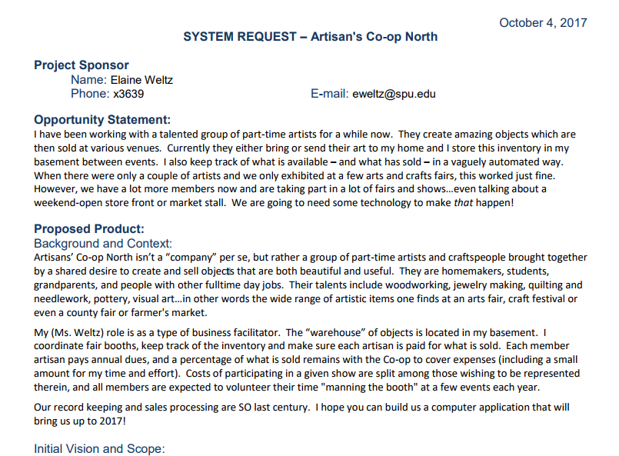

**Page 8 of 43**

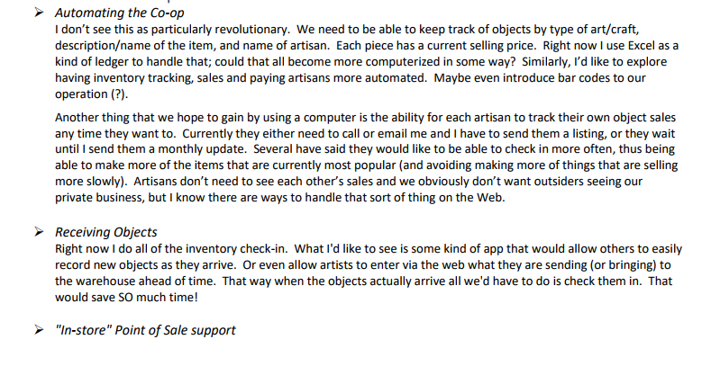

**Page 9 of 43**

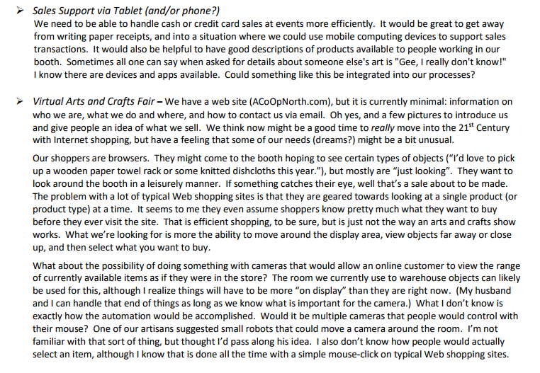

**Page 10 of 43**

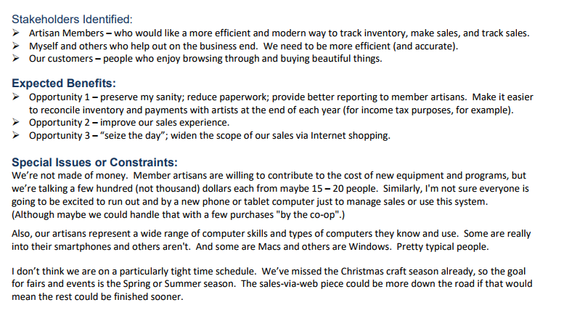

**Page 11 of 43**

**2.2 Sales Letter**

Ms. Weltz

241 Miller St., Seattle, WA 98119

Dear Ms. Weltz,

I’m writing to you in regard to the System Request you sent out about Artisan’ Co-op North. First of all, let me begin by introducing myself. My name is Richard London, and I’m a representative of Jack’s Technologies, a system development organization. We have read your System Request and believe we can fulfill it as per your requirements. Based on your request, we’ve established five issues-

1. You’re currently using excel documents to keep track of everything.
2. Artists have to call or email you to keep track of their sales.
3. You’re doing manual inventory check-in (pen and paper)
4. You’re writing paper receipts for sales.
5. You need a way for users to have better access to art products.

Based on these problems, these are the suggestions we propose (each solution corresponds to the same number above).

1. Switch to a database- store all records from the excel document into a database, and from now on, enter anything directly into the database.
2. Update “ACoOpNorth.com” to allow a user and passwords feature, and have each artist receive their own unique username and password.
3. Expanding upon #2, we update “ACoOpNorth.com” to have a check-in option on each user’s account so they can upload pictures and information about the art they’re checking in.
4. Each user will then be able to use the database to view inventory and sales of artwork that is pertinent to them.
5. Set up credit card readers on phone so instead of writing paper receipts, customers can swipe their credit card using the artist’s phone for the transaction of the sale. We will develop an application that will process the customer’s credit/debit card information.
6. Upload pictures of artwork stored in the warehouse to “ACoOpNorth.com” and our application will allow the user to view the artwork via the website. They can also zoom in and rotate the artwork.
7. We will implement an E-banking option for Ms. Weltz so she can may direct payments into her employee’s banking account.

Starting from the first point, we believe we can set you up with a database will help improve efficiency tremendously. The database will be online, and just like excel, you can make tables and edit columns/rows. However, with the database, adding, deleting, and searching through the data will be effortless. You can also have the data inside the database be displayed on any website or app you want, which is something that is not possible with excel.

Our next goal will be to improve your current website, ACoOpNorth.Com. We want to add a

**Page 12 of 43**

username/password feature so each artist will have their unique log-in credentials to store their privileged information. We will also add a check-in option on each artist’s account so that they can upload information about their artwork via the website. Finally, the website will also have a “viewing” feature for potential customers that want to browse the artwork from the comfort of their homes. They can go onto the website, click on the feature, and get access to one of many robots that will have cameras attached to it. The user can then use their mouse to control the robot to move it around the warehouse to view the artwork stored there.

Lastly, to address the final issue, I suggest that you buy Credit Card Readers. These are extensions that you can attach to your phone via the headphone slot that allows customers to swipe their credit/debit card through the reader. This will instantly conclude the purchase; much more efficient then writing paper receipts that can be lost/ruined. We can develop an app that will regulate the purchases done via the Credit Card Readers to make sure everything goes smoothly.

I hope that these solutions meet your expectations. Thank You for considering Jack’s Technologies and I look forward to hearing your response.

Sincerely,

Richard London

Jack’s Technologies Advisor

**Page 13 of 43**

1. **Feasibility Assessment**
   1. **Introduction**

JT conducted a feasibility analysis of *Artisan’s Co-op North System Upgrade* project. This coming section will cover the feasibility of *Artisan’s Co-op North System Upgrade* in 5 areas: Technical, Resource, Schedule, Organization, and Legal and Contractual. The scale for riskiness will range from 0 to 10, with 0 being very low, 5 being moderate, and 10 being extremely high. A high or extremely high risk should not be taken unless there are sufficient measures in place to placate the risk.

* 1. **Feasibility Analysis**

The Artisan’s Co-op North Project is feasible, the *risk factor being around 2*. Since the risk is low, it should be manageable with the following suggestions.

**3.2.1 Technical Feasibility**

The Artisan’s Co-op North Project is technically feasible with **low risk** for most of these aspects.

*Risk concerning user interaction with application* (**Risk Factor: 1**):

* The application designs are common sense and is similar to real world situations. UI design has an easy learning curve.
* A walkthrough will be provided if any issue or confusion occurs with interacting with the application.

*Risk concerning analyst familiarity with application area* (**Risk Factor: 0**)

* Jack’s Technologies has a plethora of experience with developing systems for business usage.

*Risk concerning development group’s familiarity with application area* (**Risk Factor: 0**)

* Jack’s Technologies’ development team has an extensive background covering a wide range of programming fields.

*Risk concerning project size* (**Risk Factor: 4**)

The project size is moderate, so any issues that may appear during development will not be difficult to handle.

*Risk concerning project structure* (Risk Factor: 2)

* The core components of the project are straightforward and most changes should be easy to implement.

**Page 14 of 43**

**3.2.2 Resource Feasibility**

The Artisan’s Co-op North Project is resource feasible with **low risk** for all of these aspects.

*Risk concerning development team* (**Risk Factor: 0**)

* As stated before, Jack’s Technologies’ development team has an extensive background that covers a wide range of expertise. Our team should be able to develop the system and solve any issues that may arise as well as implement any changes you see fit.

*Risk concerning hardware* (**Risk Factor: 2**)

* The hardware for *Artisan’s Co-op North System Upgrade* is not extensive and can be easily procured. Our developers also have extensive hardware-interface experience, which will be useful regarding the interaction between the application and the Credit Card Readers.

*Risk concerning software* (**Risk Factor: 2**)

* The software for *Artisan’s Co-op North System Upgrade* is straightforward and minor changes can be implemented easily if necessary.

*Risk concerning environment* (**Risk Factor: 1**)

* Hosting the application, database, and any hardware will be provided by Jack’s Technologies.

**3.2.3 Schedule Feasibility**

The Artisan’s Co-op North Project is schedule feasible with **low risk** for all of these aspects.

*Risk concerning core requirements by first milestone* (**Risk Factor: 2**)

* The core components of the project are straightforward and well-planned, and JT should have no problems in executing it in the way that meets your expectations.

*Risk concerning non-core requirements* (**Risk Factor: 2**)

* Non-core requirements (Customer access application) is straightforward and should be easy to implement.
* Non-core requirements involve integration with third-party systems.

**Page 15 of 43**

**3.2.4 Organizational Feasibility**

The Artisan’s Co-op North Project is organizational feasible with **moderate risk** for all of these aspects.

*Risk concerning urgency of project* (**Risk Factor: 3**)

* JT has determined that the current system is extremely outdated and the new system will improve the efficiency of Artisan’s Co-op North significantly. For this, we are making the development of the core components of the system high priority.
* However, JT has determined that the non-core components of the system (Customer access application) is of low priority. While customers will have easier access by viewing artwork via ACoopNorth.com, they have access already by visiting art booths. In the future, JT will strive to improve the application so that customers can view artwork online at their own convivence.

**3.2.5 Legal and Contractual Feasibility**

**3.2.5.1 Legal**

*Risk concerning Legal* (**Risk Factor: 3**)

* Most of the hardware-software integration don’t require legal rights to modify, so integration of them will not be a problem. However, the Credit Card Readers will have to be bought from a 3rd party organization, then modified so they will integrate with our application, so JT will need to acquire legal rights to modify and/or upgrade those hardware components.
* The application will require the users to register an account by creating a username, password, address, phone number, email, and full name. This could have potential privacy concerns, and proper industry standards should be followed for processing and storing this information.
* The application will require artists and customers to register credit card information or other payment methods. It will also require artists to register bank account details so they can receive payment. This also raises the risk of potential privacy concerns, so Industry standards should also be followed here as well.

**3.2.5.2 Contractual**

*Risk concerning Contractual* (**Risk Factor: 2**)

* In the issue of continued development, upgrades, and bug fixes, JT will remain partial owners of the completed software applications and source code for at least ten years. After the ten years, Artisan’s Co-Op North will have the option to buy sole ownership of the software and source code at a negotiable price at that time. While JT retains partial ownership, we will provide any support required for the software applications.

**Page 16 of 43**

**3.3 Additional Comments**

* Legal workers, such as lawyers, may need to be hired to acquire rights to modify 3rd party hardware such as Credit Card Readers.
* If Artisan’s Co-Op North continues to grow, then additional staff may be required by JT to continue to provide support.

**3.4 Conclusion**

* After an extensive analysis, Jack’s Technologies has deemed this project feasible with an overall risk factor of 2. The highest risk associated with this project will be acquiring rights to modify Credit Card Readers so they will integrate with our applications. These requirements can’t be solved solely through development work, and will require hiring legal workers to acquire the rights we need to start on the non-core components of the project. The schedule concerning the non-core components of the project will be contingent on the ability to acquire rights for the Readers.

**Page 17 of 43**

**4.0 Requirements Definition**

**4.1 Introduction**

The Requirements Definition will outline the requirements of Artisan’s Co-Op North Upgrade Project, and has been divided into three categories: Functional, Non-functional, and Data requirements. Functional requirements are services that the system must be able to complete. Non-functional requirements specify criteria that place constraints on the system. Data requirements specify how the software will input, output, and store data.

**4.2 Functional Requirements**

Registering and Accessing accounts (1)

* The user must be able to register for a new account by creating a unique username and a password.
* The user must then be able to log in, via ACoOpNorth.com, by using their username and password.

Database Access (4, 5)

* The user must be able to input information about their artwork into the database.
* The user must be able to view information about artwork from the database.
* The database must be able to categorize information based on fields requested by the user.
* The user must be able to track inventory and sales using the database.

Customer Access (6, 7)

* The customer, via ACoopNorth.com, must be able to access pictures of artwork stored in the warehouse.
* The customer must be able to zoom-in and rotate the artwork (view it as a 3D Model).

Automated Payment option (6)

* Ms. Weltz must be able to make payments directly into the bank accounts of employees using E-banking.

**4.3 Data Requirements**

* User can store contact information (full name, email, and phone number).
* Users must be able to store all pertinent information about their artwork (price, size, description, data created, date sold, and any other requested fields).
* The database must support at least 1000 users.

**Page 18 of 43**

**4.4 Nonfunctional Requirements**

Security Issues

* Each artist must only be able to view inventory and sales of artwork that belongs to them.
* Customers must only be able to view artwork from the warehouse.
* Only Ms. Weltz must be able to view all artists’ banking information and make payments to them.
* Only Ms. Weltz can access all information stored in database by all artists.

System Interface

* Only Ms. Weltz can upload pictures onto ACoOpNorth.com for customer access.
* Only Ms. Weltz can check-in artwork that arrive at the warehouse.

Documentation

* Only the artist who created the artwork must be able to modify information about the artwork in the database.

Performance Characteristics

* The database must support at-least 1000 users.
* The database should respond to user requests fast.
* The system should retain a 98% uptime.
* The system can’t be down for no longer than 30 minutes for maintenance during peak-time, and two hours for off-time.

User Interface

* The mobile and web application must have an easy learning curve and come with a walkthrough to remove the need for training.
* The mobile application must be available on Android, iOS, and Windows.
* The mobile application must be available for free for the users.
* The web application must be available on Google Chrome, Microsoft Edge, Mozilla Firefox, and Internet Explorer.

**Page 19 of 43**

**5.0 Requirements Model**

**5.1 Introduction**

The following pages give a deeper look into the flow of the application as well as the components and interconnected parts that make the application. The following diagram is a Use-Case diagram that shows how the individual parts of the application interact with the environment as well as other parts of the application. Arrows and lines represent relations between actions and actors.

The Use-Case descriptions offer a further in-depth look at the relations and purposes of the use-cases in the Use-Case diagram. They describe what the user’s expected use of system will look like, as well as considerations necessary to complete tasks (if needed).

**Page 20 of 43**

**5.2 Use-Case Diagram**

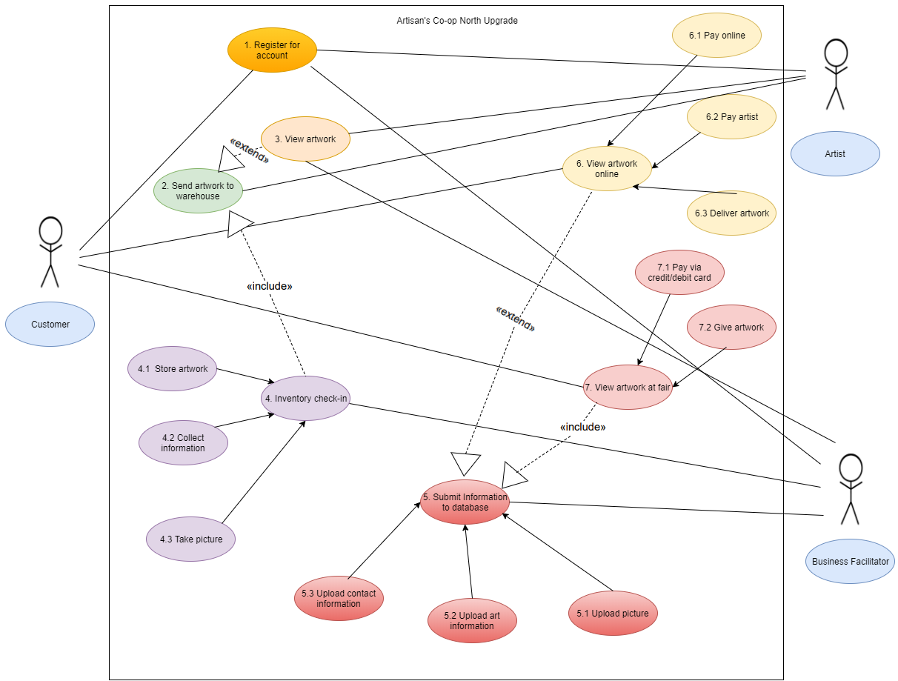

**Page 21 of 43**

**Use-Case Descriptions**

|  |  |  |  |
| --- | --- | --- | --- |
| **Use-Case name**: Register for account | | **ID**: 1 | **Importance**: High |
| **Primary actor**: Artist, Business Facilitator | **Use-Case type**: Essential | | |
| **Stakeholders and interests**:  Artist: Wants to be able to view inventory and track sales online  Business Facilitator: Wants to be able to upload artwork information, contact information, and pictures of artwork from warehouse, as well as pay artists for sold artwork. | | | |
| **Brief description**:  Register option allows user to create a username and password for account. Signing into page accesses the website. Entering username and password will undergo authentication procedures. If wrong information is entered, access is denied, and user gets another opportunity to reenter credentials. | | | |
| **Trigger**: User goes to “ACoopNorth.com” and clicks “Login”  **Type** (circle one): External Temporal | | | |
| **Relationships**:  **Association**: Artist, Business Facilitator  **Include**: N/A  **Extend**: N/A  **Generalization**: N/A | | | |
| **Normal flow of events**:  1. User goes to website  2. User opens login window  3. User types in user credentials  4. Information is sent to application and validated if unique username and email. Notification is sent to user whether this is successful.  5. Email is sent to corresponding email account to confirm account registration. | | | |
| **Subflows**: N/A | | | |
| **Alternate / exceptional flows**: N/A | | | |

**Page 22 of 43**

|  |  |  |  |
| --- | --- | --- | --- |
| **Use-Case name**: Send artwork to warehouse | | **ID**: 2 | **Importance**: High |
| **Primary actor**: Artist | **Use-Case type**: Essential, Detail | | |
| **Stakeholders and interests**:  Artist: Sends in artwork so business facilitator can upload information to website | | | |
| **Brief description**:  Artist ships their artwork to the business facilitator’s warehouse. | | | |
| **Trigger**: Artist ships artwork to warehouse.  **Type** (circle one): External Temporal | | | |
| **Relationships**:  **Association**: Artist  **Include**: N/A  **Extend**: 3. View Artwork  **Generalization**: N/A | | | |
| **Normal flow of events**:  1. Artist 4. Inventory check-in  2. Artist ships artwork to warehouse. | | | |
| **Subflows**: N/A | | | |
| **Alternate / exceptional flows**: N/A | | | |

**Page 23 of 43**

|  |  |  |  |
| --- | --- | --- | --- |
| **Use-Case name**: View artwork | | **ID**: 3 | **Importance**: High |
| **Primary actor**: Artist, Business Facilitator | **Use-Case type**: Essential, Detail | | |
| **Stakeholders and interests**:  Artist: Views artwork to ensure it arrived safely and without any damage.  Business Facilitator: Views artwork to make sure it matches artist’s description and is undamaged. | | | |
| **Brief description**:  Artist and Business Facilitator view the artwork that arrived at the warehouse. | | | |
| **Trigger**: Viewing artwork.  **Type** (circle one): External Temporal | | | |
| **Relationships**:  **Association**: Artist  **Include**: N/A  **Extend**: N/A  **Generalization**: N/A | | | |
| **Normal flow of events**:  1. Artwork arrives at warehouse.  2. Artists views artwork to make sure that its undamaged.  3. Business Facilitator views artwork to make sure it matches artist’s description and is undamaged. | | | |
| **Subflows**: N/A | | | |
| **Alternate / exceptional flows**: N/A | | | |

**Page 24 of 43**

|  |  |  |  |
| --- | --- | --- | --- |
| **Use-Case name**: Send artwork to warehouse | | **ID**: 4 | **Importance**: High |
| **Primary actor**: Business Facilitator | **Use-Case type**: Essential, Detail | | |
| **Stakeholders and interests**:  Business Facilitator: Checks-in artwork to prepare it to be viewed and sold. | | | |
| **Brief description**:  Business Facilitator checks in artwork into the warehouse. They can then store the artwork, collect information about it, and take a picture of the artwork. | | | |
| **Trigger**: Artist ships artwork to warehouse.  **Type** (circle one): External Temporal | | | |
| **Relationships**:  **Association**: Artist  **Include**: 2. Send artwork to warehouse  **Extend**: N/A  **Generalization**: 4.1 Store artwork, 4.2 Collect information, 4.3 Take picture | | | |
| **Normal flow of events**:  1. Business facilitator checks in artwork to warehouse.  2. Business facilitator decides which method they would like to use.  3. 4.1 Store artwork, 4.2 Collect information, 4.3 Take picture is used | | | |
| **Subflows**: N/A | | | |
| **Alternate / exceptional flows**: N/A | | | |

**Page 25 of 43**

|  |  |  |  |
| --- | --- | --- | --- |
| **Use-Case name**: Store artwork | | **ID**: 4.1 | **Importance**: High |
| **Primary actor**: Business Facilitator | **Use-Case type**: Essential, Detail | | |
| **Stakeholders and interests**:  Business Facilitator: Views artwork to make sure it matches artist’s description and is undamaged. | | | |
| **Brief description**:  Business Facilitator stores artwork inside the warehouse after checking its condition. | | | |
| **Trigger**: Storing artwork into warehouse.  **Type** (circle one): External Temporal | | | |
| **Relationships**:  **Association**: Business Facilitator  **Include**: N/A  **Extend**: N/A  **Generalization**: N/A | | | |
| **Normal flow of events**:  1. Business Facilitator choses to do 4. Store artwork  2. Business Facilitator checks condition of the artwork  3. If satisfactory, the artwork is stored inside the warehouse.  4. If artwork has damage, Business Facilitator is contacted. | | | |
| **Subflows**: N/A | | | |
| **Alternate / exceptional flows**:  4.1a) If artwork doesn’t match artist’s description, or the artwork is damaged, the Business Facilitator contacts the artist and informs them. | | | |

**Page 26 of 43**

|  |  |  |  |
| --- | --- | --- | --- |
| **Use-Case name**: Collect information | | **ID**: 4.2 | **Importance**: High |
| **Primary actor**: Business Facilitator | **Use-Case type**: Essential, Detail | | |
| **Stakeholders and interests**:  Business Facilitator: Makes sure artwork information is accurate to ensure a successful sale to receive commission. | | | |
| **Brief description**:  Business Facilitator collects information about the artwork. | | | |
| **Trigger**: Collects information about artwork.  **Type** (circle one): External Temporal | | | |
| **Relationships**:  **Association**: Business Facilitator  **Include**: N/A  **Extend**: N/A  **Generalization**: N/A | | | |
| **Normal flow of events**:  1. Business Facilitator choses to do 4. Collection information.  2. Business Facilitator collects information to later upload into database and website. | | | |
| **Subflows**: N/A | | | |
| **Alternate / exceptional flows**: N/A | | | |

**Page 27 of 43**

|  |  |  |  |
| --- | --- | --- | --- |
| **Use-Case name**: Take picture | | **ID**: 4.3 | **Importance**: High |
| **Primary actor**: Business Facilitator | **Use-Case type**: Essential, Detail | | |
| **Stakeholders and interests**:  Business Facilitator: Takes picture of artwork so customer can see artwork clearly to ensure a successful sale to gain commission. | | | |
| **Brief description**:  Business Facilitator takes picture of artwork. | | | |
| **Trigger**: Storing artwork into warehouse.  **Type** (circle one): External Temporal | | | |
| **Relationships**:  **Association**: Business Facilitator  **Include**: N/A  **Extend**: N/A  **Generalization**: N/A | | | |
| **Normal flow of events**:  1. Business Facilitator choses to do 4. Take picture.  2. Business Facilitator takes picture of artwork to later upload into database and website. | | | |
| **Subflows**: N/A | | | |
| **Alternate / exceptional flows**: N/A | | | |

**Page 28 of 43**

|  |  |  |  |
| --- | --- | --- | --- |
| **Use-Case name**: Submit information to database. | | **ID**: 5 | **Importance**: High |
| **Primary actor**: Business Facilitator | **Use-Case type**: Essential, Detail | | |
| **Stakeholders and interests**:  Business Facilitator: Takes picture of artwork so customer can see artwork clearly to ensure a successful sale to gain commission. | | | |
| **Brief description**:  Business Facilitator inputs information into database. | | | |
| **Trigger**: Submitting information.  **Type** (circle one): External Temporal | | | |
| **Relationships**:  **Association**: Business Facilitator  **Include**: 7. View artwork at fair  **Extend**: 6. View artwork online  **Generalization**: 5.1 Upload picture, 5.2 Upload art information, 5.3 Upload contact information. | | | |
| **Normal flow of events**:  1. Business Facilitator choses to do 4. Take picture.  2. Business Facilitator takes picture of artwork to later upload into database and website. | | | |
| **Subflows**: N/A | | | |
| **Alternate / exceptional flows**: N/A | | | |

**Page 29 of 43**

|  |  |  |  |
| --- | --- | --- | --- |
| **Use-Case name**: Upload picture | | **ID**: 5.1 | **Importance**: High |
| **Primary actor**: Business Facilitator | **Use-Case type**: Essential, Detail | | |
| **Stakeholders and interests**:  Business Facilitator: Uploads picture of artwork onto website so customer can view it at their own convivence. | | | |
| **Brief description**:  Business Facilitator uploads pictures of artwork into website. | | | |
| **Trigger**: Submitting information.  **Type** (circle one): External Temporal | | | |
| **Relationships**:  **Association**: Business Facilitator  **Include**: N/A  **Extend**: N/A  **Generalization**: | | | |
| **Normal flow of events**:  1. Business Facilitator chose to do 5. Upload picture  2. Business Facilitator uploads picture of artwork onto ACoopNorth.com  3. Business Facilitator stores picture into database. | | | |
| **Subflows**: N/A | | | |
| **Alternate / exceptional flows**: N/A | | | |

**Page 30 of 43**

|  |  |  |  |
| --- | --- | --- | --- |
| **Use-Case name**: Upload art information | | **ID**: 5.2 | **Importance**: High |
| **Primary actor**: Business Facilitator | **Use-Case type**: Essential, Detail | | |
| **Stakeholders and interests**:  Business Facilitator: Uploads relevant artwork information onto ACoopNorth.com so customers can view it at their own convivence. | | | |
| **Brief description**:  Business Facilitator uploads artwork onto website. | | | |
| **Trigger**: Uploading artwork.  **Type** (circle one): External Temporal | | | |
| **Relationships**:  **Association**: Business Facilitator  **Include**: N/A  **Extend**: N/A  **Generalization**: | | | |
| **Normal flow of events**:  1. Business Facilitator chose to do 5.2 Upload artwork information,  2. Business Facilitator uploads artwork information onto ACoopNorth.com  3. Business Facilitator stores artwork information onto database. | | | |
| **Subflows**: N/A | | | |
| **Alternate / exceptional flows**: | | | |

**Page 31 of 43**

|  |  |  |  |
| --- | --- | --- | --- |
| **Use-Case name**: Upload contact information | | **ID**: 5.3 | **Importance**: High |
| **Primary actor**: Business Facilitator | **Use-Case type**: Essential, Detail | | |
| **Stakeholders and interests**:  Business Facilitator: Uploads contact information about artists so customers can contact them about purchasing artwork. | | | |
| **Brief description**:  Business Facilitator uploads contact information of the artist. | | | |
| **Trigger**: Uploading contact information.  **Type** (circle one): External Temporal | | | |
| **Relationships**:  **Association**: Business Facilitator  **Include**: N/A  **Extend**: N/A  **Generalization**: | | | |
| **Normal flow of events**:  1. Business Facilitator chose 5.3. Upload contact information.  2. Business Facilitator uploads contact information of artist onto ACoopNorth.com  3. Business Facilitator uploads contact information of artist into database. | | | |
| **Subflows**: N/A | | | |
| **Alternate / exceptional flows**:  5.3a) If artist’s contact information is already in database, database will ask user if they want to replace existing information. | | | |

**Page 32 of 43**

|  |  |  |  |
| --- | --- | --- | --- |
| **Use-Case name**: View artwork online | | **ID**: 6 | **Importance**: High |
| **Primary actor**: Customer | **Use-Case type**: Essential, Detail | | |
| **Stakeholders and interests**:  Customer: Views artwork online to decide whether they want to purchase it or not.  Artist: Wants ease of access for customer so more customers can view their artwork, increasing the chances of someone purchasing the artwork. | | | |
| **Brief description**:  Customer views artwork via ACoopNorth.com | | | |
| **Trigger**: Submitting information.  **Type** (circle one): External Temporal | | | |
| **Relationships**:  **Association**: Customer  **Include**: N/A  **Extend**: N/A  **Generalization**: 6.1 Pay online, 6.2 Pay artist, 6.3 Deliver artwork | | | |
| **Normal flow of events**:  1. Customer views artwork and decides whether to purchase the artwork.  2. If so, customer goes to 6.1.  3. If not, artwork remains on display to be sold. | | | |
| **Subflows**: N/A | | | |
| **Alternate / exceptional flows**:  6a) For 6.1- currently, paying online only accepts Visa and Mastercard. Anything else gives a warning.  6b) For 6.2- Paying artist must be a direct deposit into their bank account.  6c) If customer lives internationally, then a shipping charge will be added for international deliveries. | | | |

**Page 33 of 43**

|  |  |  |  |
| --- | --- | --- | --- |
| **Use-Case name**: Pay online | | **ID**: 6.1 | **Importance**: High |
| **Primary actor**: Customer | **Use-Case type**: Essential, Detail | | |
| **Stakeholders and interests**:  Customer: Pays the artist so they can take the artwork with them.  Artist: Needs customer to pay for artwork so they make money.  Business Facilitator: Needs customer to pay for artwork so they receive their commission. | | | |
| **Brief description**:  Customer pays for the artwork via ACoopNorth.com | | | |
| **Trigger**: Paying for artwork.  **Type** (circle one): External Temporal | | | |
| **Relationships**:  **Association**: Customer, Artist  **Include**: N/A  **Extend**: N/A  **Generalization**: N/A | | | |
| **Normal flow of events**:  1. Customer chose to do 6.1 Pay Online.  2. The customer pays for the artwork online, and the money is sent to Ms. Weltz. | | | |
| **Subflows**: N/A | | | |
| **Alternate / exceptional flows**:  6.1a) Currently, paying online only accepts Visa and Mastercard. Any other credit/debit card, or other payment method, will give the user a warning. The user can choose to write a check to Ms. Weltz if they have no other options. | | | |

**Page 34 of 43**

|  |  |  |  |
| --- | --- | --- | --- |
| **Use-Case name**: Pay artist | | **ID**: 6.2 | **Importance**: High |
| **Primary actor**: Business Facilitator | **Use-Case type**: Essential, Detail | | |
| **Stakeholders and interests**:  Business Facilitator: Pays corresponding artist for the artwork that was sold. Gets a part of sale price as commission.  Artist: Makes money for sold artwork. | | | |
| **Brief description**:  Business Facilitator pays artist via Ebank. | | | |
| **Trigger**: Pays artist.  **Type** (circle one): External Temporal | | | |
| **Relationships**:  **Association**: Business Facilitator, Artist  **Include**: N/A  **Extend**: N/A  **Generalization**: N/A | | | |
| **Normal flow of events**:  1. Ms. Weltz receives payment from the customer for the sold artwork.  2. Ms. Weltz keeps her commission, and deposits rest of the money directly into the artist’s bank account. | | | |
| **Subflows**: N/A | | | |
| **Alternate / exceptional flows**: | | | |

**Page 35 of 43**

|  |  |  |  |
| --- | --- | --- | --- |
| **Use-Case name**: Deliver artwork | | **ID**: 6.3 | **Importance**: High |
| **Primary actor**: Business Facilitator | **Use-Case type**: Essential, Detail | | |
| **Stakeholders and interests**:  Customer: Gets artwork they paid for. | | | |
| **Brief description**:  Business Facilitator delivers artwork to customer’s address, or customer picks up artwork. | | | |
| **Trigger**: Delivering artwork  **Type** (circle one): External Temporal | | | |
| **Relationships**:  **Association**: Customer, Business Facilitator  **Include**: N/A  **Extend**: N/A  **Generalization**: | | | |
| **Normal flow of events**:  1. Customer has the option for pickup or drop-off.  2. If pick-up, customer comes to warehouse and picks up the artwork.  3. If drop-off, the customer provides their address and the artwork is delivered to their home via USPS. | | | |
| **Subflows**: N/A | | | |
| **Alternate / exceptional flows**:  6.3a) If customer lives internationally, then a shipping charge will be added for international deliveries. | | | |

**Page 36 of 43**

|  |  |  |  |
| --- | --- | --- | --- |
| **Use-Case name**: View artwork at Fair | | **ID**: 7 | **Importance**: High |
| **Primary actor**: Customer | **Use-Case type**: Essential, Detail | | |
| **Stakeholders and interests**:  Customer: Views artwork to decide whether they’re interested in purchasing artwork.  Artist: Gets paid if their artwork sells.  Business Facilitator: Receives commission if artwork is sold. | | | |
| **Brief description**:  Customer views artwork at fair. | | | |
| **Trigger**: Views artwork at fair.  **Type** (circle one): External Temporal | | | |
| **Relationships**:  **Association**: Customer, Artist  **Include**: N/A  **Extend**: N/A  **Generalization**: 7.1 Pay via credit/debit card, 7.2 Give artwork | | | |
| **Normal flow of events**:  1. Customer views artwork and chooses whether to purchase it.  2. If customer chooses to purchase artwork, go to 7.1.  3. If not, artwork remains on display to be sold. | | | |
| **Subflows**: N/A | | | |
| **Alternate / exceptional flows**:  7a) On the initial release, the credit card readers can only accept Mastercard or Visa. If this is an inconvenience, the user can pay cash or check. If so, the artist is required to inform Ms. Weltz of the cash or check payment. | | | |

**Page 37 of 43**

|  |  |  |  |
| --- | --- | --- | --- |
| **Use-Case name**: Pay via credit/debit card | | **ID**: 7.1 | **Importance**: High |
| **Primary actor**: Customer | **Use-Case type**: Essential, Detail | | |
| **Stakeholders and interests**:  Business Facilitator: Gets part of sale price as commission.  Customer: Gets to keep artwork they paid for.  Artist: Makes money for sold artwork. | | | |
| **Brief description**:  Customer purchases artwork. | | | |
| **Trigger**: Submitting information.  **Type** (circle one): External Temporal | | | |
| **Relationships**:  **Association**: Customer  **Include**: N/A  **Extend**: N/A  **Generalization**: N/A | | | |
| **Normal flow of events**:  1. Customer chooses to purchase the artwork, and pays with a credit or debit card.  2. The customer swipes the card using the credit card reader, and the money is deposited directly into the artist’s bank account.  3. The artist withdraws some of the money and gives to Ms. Weltz for commission. | | | |
| **Subflows**: N/A | | | |
| **Alternate / exceptional flows**:  7.1a) On the initial release, the credit card readers can only accept Mastercard or Visa. If this is an inconvenience, the user can pay cash or check. If so, the artist is required to inform Ms. Weltz of the cash or check payment. | | | |

**Page 38 of 43**

|  |  |  |  |
| --- | --- | --- | --- |
| **Use-Case name**: Give artwork | | **ID**: 7.2 | **Importance**: High |
| **Primary actor**: Artist | **Use-Case type**: Essential, Detail | | |
| **Stakeholders and interests**:  Customer: Gets artwork they paid for.  Artist: Gets recognition and exposure. | | | |
| **Brief description**:  Artist gives artwork to customer. | | | |
| **Trigger**: Submitting information.  **Type** (circle one): External Temporal | | | |
| **Relationships**:  **Association**: Artist, Customer  **Include**: N/A  **Extend**: N/A  **Generalization**: N/A | | | |
| **Normal flow of events**:  1. The artist gives the customer the artwork they bought.  2. If the customer can’t take the artwork then, the artist will note down the customer’s address and ship it to them via USPS. | | | |
| **Subflows**: N/A | | | |
| **Alternate / exceptional flows**: N/A | | | |

**Page 39 of 44**

**6.0 System Evolution**

**System Modifications**

* **The database will need to be constantly updated as artwork is entered and sold.**
* **Initial System will consist of core requirements. We will add features such as password recovery as enhancements on a later date.**
* **Each of these features will be subject to many changes and upgrades throughout their lifetime.**
* **Performance-wise, database and website access must perform most efficiently in the United States.**

**Physical Environment**

* **Application needs to be compatible with different operating systems, such as Windows. It may start off only compatible on Windows 10, but future updates need to add accessibility to Android and iOS.**
* **Application be able operable on Wi-Fi. Furthermore, application must consume a low amount of data, so users open and run the application in fairs or other locations where they don’t have access to a wireless network.**

**Environmental Changes**

* **Database access must be world-wide to support international sales but especially important performance wise in the United States. This application must be accessible in multiple countries, and needs to be released in English. Further updates will allow the application to be run in different languages.**

**Resource and Management Issues**

* **As per the contract, Jack’s Technologies will take care of ongoing maintenance and support for the application within the timeframe specified in the contract.**
* **Jack’s Technologies will handle all bug fix requests and enhancement upgrades.**

**Page 40 of 44**

**7.0 Conclusions and Recommendations**

**7.1 Conclusions**

**Artisan’s Coop North Upgrade’s planning and analysts have been finished. The project has a clear vision and scope. The feasibility of the project is well-understood, and the risks have been analyzed and countermeasures can be deployed should the need arise. The system will require multiple releases, but the main core components will all be included in the first release. Further releases will add non-essential features as well as upgrades to current components. Further work will be needed for integration with third-party features such as the Credit Card Reader as that has not been fully developed.**

**7.2 Recommendations**

**Jack’s Technologies make the following recommendations:**

* **Jack’s Technologies will negotiate with companies to gain the rights to integrate their Credit Card Readers into our applications.**
* **Artisan’s Coop North, Jack’s Technologies, and third-party companies should meet and discuss feasibility.**
* **We will reevaluate risk assessments after negotiations are over.**

**Overall, the project is going smoothly, and we should focus on these recommendations next.**

**Page 41 of 43**

**Appendices**

**Glossary**

* Database- A structured set of data held in a computer, especially one that is accessible in various ways.
* Functional Requirements- services that the system must be able to complete
* Non-functional Requirements- requirements specify criteria that place constraints on the system
* Data Requirements- specify how the software will input, output, and store data

**Page 42 of 43**

**Bibliography**

* Dennis, Wixom, Tegarden, et al. Systems Analysis and Design: An Object Oriented Approach with UML, 5th Edition. Vol. 5th, Wiley, 2016.Print.
* Weltz, Elaine (2017). Systems Design, lectures [PowerPoint slides/Word Documents]. Retrieved from Professor Weltz and http://spu.edu.
* Pfeiffer, William S. Pocket Guide to Technical Communication. Upper Saddle River, NJ: Prentice Hall, 2011. Print.

**Page 43 of 43**